S’no Problem Weather Index

Billy Clark
Dillon Durinick
Travis Patterson
Jordan Root
Heather Waldman

Table of Contents

Introduction……….1
Meteorological Information and Data……….2
Potential Savings for Weis Markets……….13
Interview with a Weis Markets Owner……….17
Description of Index..........18
Product Example……….26
Guidelines……….30
Contract……….33
Supplemental Resources and References……….37

Introduction

S’no Problem Weather Index (SPWI) developed by TriplePoint has been created, circa 2013, with the intent of saving Weis Markets Inc. money through the implementation of a winter weather index. SPWI will examine upcoming weather events, produce an index based on the conditions, and provide guidelines and recommendations to improve business during times of inclement weather. Meteorological information behind the SPWI, potential savings for Weis Markets, an interview with a Weis Market owner, a detailed description of the index, guidelines for the index, and a contract can be found below.

Meteorological Information and Data
As our company motto states, TriplePoint is dedicated to combining the best of business strategy, communication and weather knowledge. Weis Markets already presents itself as a strong and profitable company but by using our forecasts, you have the potential to increase profits substantially. Our team members have a combined fifteen plus years of forecasting experience in Pennsylvania and surrounding regions. Weis Markets should use our skills to its advantage in order to not only maximize profits, but also to keep customers and employees as satisfied as possible.
The science of meteorology was crafted from humble roots using nothing but keen observation skills and pattern recognition. Such careful observation over the last several hundred years has led to the organization of many major data networks including the National Climatic Data Center, CoCoRahs (which handles observation of precipitation) as well as climatology offices in each of the fifty states. The Pennsylvania State Climatology Office is located right at Penn State University’s main campus within the meteorology department and it provides a myriad of data from temperatures to precipitation to wind. These observation networks have become the bedrock for weather prediction: in order to have a grasp of what is going to happen, we must first know all that we can about what is happening at this very moment.
Numerical Weather Prediction, which is the use of various physical equations and statistics to create a weather forecast, began in its simplest form over 200 years ago when it was suggested that the mysteries of the atmosphere could be solved through mathematics. From there, coarse conceptual models were refined by use of better prediction methods and faster computers as well as greater access to more reliable observation data. One of the most widely used forecasting tools in the United States is model output statistics (MOS). MOS is run in two major branches: the North American Model (NAM) and the Global Forecasting System (GFS) both of which operate by creating a “best guess” forecast in conjunction with a set of current observations. After several cycles of the models ingesting more observations and verifying their ‘first guess forecast’, they are able to create detailed forecasts of temperature, wind speed and direction, precipitation, visibility and other useful variables on a very localized scale. What makes MOS unique is that it contains a bank of data that helps it determine what happened on previous days given a specific set of initial weather conditions. TriplePoint will use MOS and other such models to create the best possible forecast for Weis Markets to serve as a planning tool for all storeowners and managers. An example of output from MOS is shown below. The forecast is for University Park, PA and values are provided in three hour intervals where 12z (Greenwich Mean Time) is equal to 7am local time during Daylight Saving Time and 8am during Standard Time.
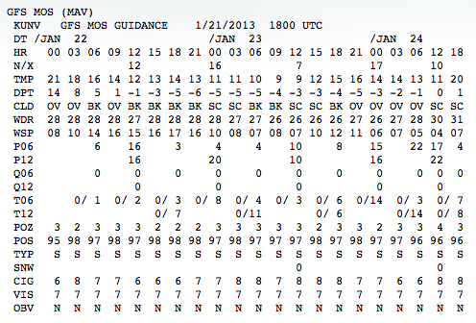
The graphics below from a study conducted in 2006 depict the vast improvements in MOS alone in both temperature and precipitation in the warm (late spring, summer, early fall) and cold (late fall, winter, early spring) seasons. The vertical axis shows the model absolute error (or MAE) for the local (MOS produces highly localized forecasts, each of which was verified against what actually happened at a specific location) high temperature each year in degrees Fahrenheit. Plots for both a 24 and 48 hour forecast are shown. Notice the substantial improvement in the one day high temperature forecast in the cold season just since 1996. Such improvements are continuing as faster computers are built and more reliable data is used. Accurate temperature forecasts provided by MOS and analyzed by our meteorologists will be necessary in determining types of precipitation when forecasting winter weather events.

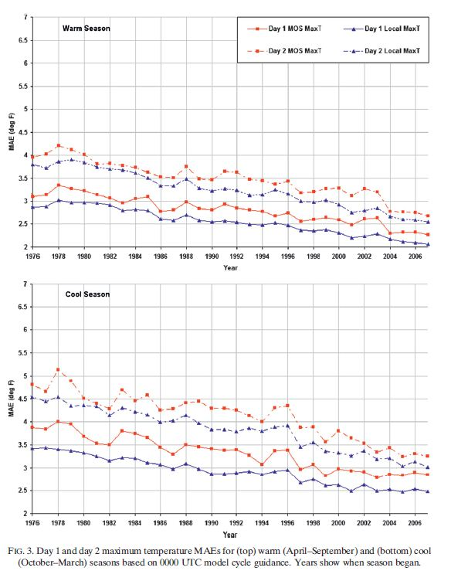

The next set of graphs shown depicts MOS improvement in another staple variable in the “S’no Problem” weather index: precipitation. Like the temperature graphs, these two show improvements in model absolute error each year for the past 30 years. The analysis of this data is a bit more compicated. Error is shown on the vertical axis in the form of a brier score. The brier score is calculated by taking a forecast probability of precipitation and either subtracting it from one if precipitation occurs; or zero if the event does not occur. The difference between the two numbers is then squared so the result is positive. The best possible brier score is a 0 while a ‘bust’ would yield a score of 1. For example, a forecast of a 70% chance of rain where it actually rained would give the following:
(1 - .7) = .3 .3*.3 = .09
The trends in precipitation forecasts are much more erratic from year to year than temperature, however the general trend is once again for significant improvement in precipitation probability forecasts.

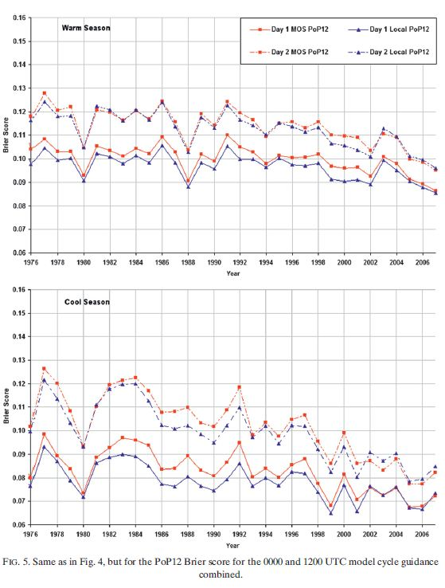

In addition to the GFS and NAM MOS models, several other models exist that are more graphical in nature that produce forecasts on a four kilometer grid in the short range (out to 48 hours). Such models can only actually resolve meteorological events down to twelve kilometers (equivalent to a large thunderstorm or intense band of snow). However, having such knowledge at your use would allow your company to better prepare inventory orders and plan for potential weather related expenses.
Despite the demonstrated model improvements, models alone are not enough. If they were enough, companies would not spend the money to employ a meteorologist to interpret different model solutions. The bottom line is that models are nothing more than computers programmed to do a specific job, and that means they cannot possibly think for themselves. The meteorologist is the one that utilizes actual knowledge of factors like terrain and other complicated weather variables that current models cannot even consider. Numerical models also lose a significant amount of skill beyond day seven. This means that more often than not, simply going by climatology could be a better forecast. It is this added analysis that fine tunes model solutions into extremely reliable forecasts for up to weeks in advance.
In addition to MOS, several other forecast and data sources will be utilized in the “S’no Problem Weather Index”. One of them is a forecast of vertical profiles of temperature in specific locations. Data will be coming from TwisterData.com, which gives output soundings for the NAM and GFS MOS as well as several other model types. These profiles or “Skew-T Log-P” diagrams are very useful tools because they show how temperature changes with height throughout the layer of the atmosphere where weather occurs. An example of a Skew-T is shown below. Temperature is plotted on the horizontal axis with lines of constant temperature extending up and to the right at 45-degree angles. Pressure in hectopascals (or millibars) is plotted on the vertical axis.
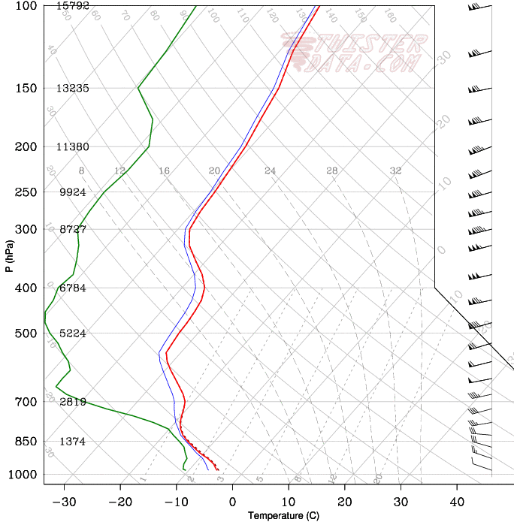
The key factor here will be to look at where temperatures are above and below freezing. A sounding showing below freezing temperatures throughout indicates snow, while a pocket of above freezing air above the surface could yield freezing rain or sleet depending on the height of this “warm pocket”. These charts also show moisture by plotting both temperature and dewpoint. The closer the temperature is to the dewpoint, the more moist a layer is. More moisture in the air tends to yield higher precipitation amounts.
Another key tool will be another precipitation forecast technique known as the Short Range Ensemble Forecast (SREF). This particular method utilizes 21 different model runs for each set of data output. Each of the different model runs uses a different set of initial weather conditions before it solves the physical equations in its programming and then creates an average forecast. This so-called “consensus forecast” is the most accurate possible because the model incorporates possible outlier solutions. This model is relatively short range and runs up to 87 hours out. This model will be used to forecast precipitation timing, amount and type. An example of SREF output is shown below. The left panel shows probability the precipitation will be snow while the right panel shows probability that precipitation will be rain.
Both the soundings from TwisterData and the output from the SREFs provide a forecast for precipitation type. It is still important to include both. The SREF forecasts are a consensus of 21 different models. Therefore, potential outlier situations are worked into the average. The SREFs also only produce precipitation type forecasts for the surface. In order to get a more accurate picture, it is important to study conditions throughout the troposphere (up to ten kilometers). Soundings allow meteorologists to examine small details at all level of the atmosphere in a more “top down” format than the graphic representations in the SREFs. A combination of the interpretations of each model method will allow us to provide the most insightful and accurate forecast possible.
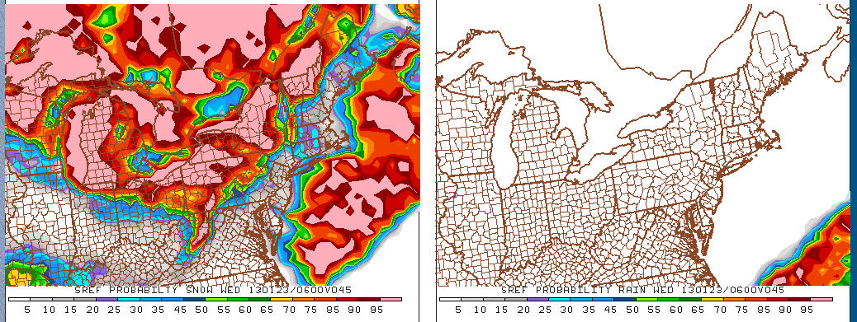
In addition to raw model forecasts, it is also a good idea to take other forecaster’s ideas into consideration. That is why we also plan to use precipitation forecasts from the Hydrometeorological Prediction Center. The government runs this organization as a part of the National Oceanic and Atmospheric Administration within the Department of Commerce. The specific products we will consider in our forecasts are the 1, 4, 8 and 12-inch snowfall forecasts produced by the HPC. Each of these products runs out to 72 hours. The advantage here is once again the value of human interpretation of the models to add to our own consensus forecast. A sample of the HPC’s forecast for one inch or more of snow is shown below.
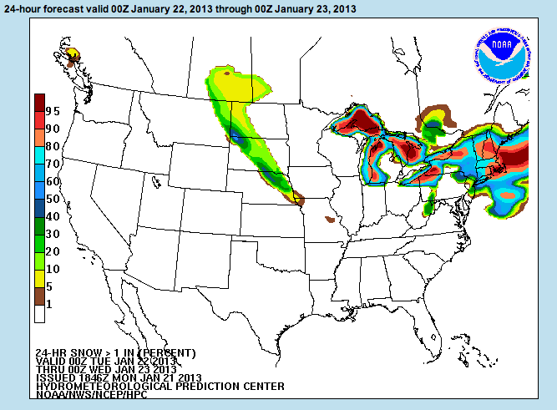
Other resources will be various data networks including the Pennsylvania State Climatologist’s Office (which was described earlier) and the National Operational Hydrologic Remote Sensing Center (NOHRSC). This group is also run through the government and would be used specifically as a database for current snow cover. The NOHRSC also provides products for snow melt and non-snow precipitation which can be used to forecast re-freezing and icing conditions.
Meteorologists have been utilized as key members of organizations in a wide range of industries. In fact, the so-called “private sector” field has increased substantially just over the last few years. Energy companies have relied on meteorologists to save them millions of dollars each year by providing accurate forecasts for energy futures. Insurance companies need meteorologists to provide statistics for natural hazards as well as investigate past weather related damage reports. As of 2006, over twenty different industries (1) employed a total of 7,200 meteorologists within their companies. The five meteorologists at TriplePoint hope to provide similar value to Weis Markets by use of our ‘S’no Problem’ winter weather index.

Weis Market Potential Savings

The S’no Problem Weather Index (SPWI) would be crucial in saving Weis Markets money in adverse winter weather conditions. The main areas that money can be saved are in reducing spoilage of perishable items, maximizing profit and stocking up on staple items usually bought before the storm, more efficiently managing labor, and giving forewarning and incite on when to post sales. In talking with a Weis manager Will McDevitt, Gilbertsville, PA location, we found some more exact numbers and information on spoilage and shipping routines. Will said that there is about a 5% shrink in value each month. Shrink refers to losses due to spoilage, reduced prices due to aging product, and unfortunately also theft. Around 2% of that 5% is due to spoilage of product. Considering that the cost of goods sold at Weis in 2011 is $2,016,649,000, and that there are 161 stores, this store would have sold around $12,525,770. A 2% spoilage cost for this store alone comes to $250,515 and if you take this store as an average, $40,332,979 is lost to spoilage over the entire franchise. This is a great expense to a company that doesn’t have the greatest of profit margins due to the competitiveness of the grocery store business.
Now there is no way, even with a perfect index, to drop the spoilage numbers to 0, but we think that a .5% improvement to only 1.5% spoilage is possible if sales of perishable food items were better coordinated to the rush of shoppers before impending storms. More shoppers will go to Weis instead of competing grocery stores if their prices were much more enticing, allowing them to sell perishable food before it spoils. We found out from him that online sales are set 3 days prior to sale date, and newspaper ads are put in the Thursday paper for sales that start on the coming Tuesday. That .5% savings would net this store $62,628, and Weis overall could save $10,083,244 in additional profits each year. In addition to this savings, our product would allow Weis to more efficiently order and ship their products to correspond with the increased demand that comes before an impending storm, and the decreased demand during a storm. We learned that a perishable truck costs 37-40 thousand dollars in shipping fees. If we advised Weis not to have a perishable delivery on the day of a storm, due to severely reduced customers, then we could save them the fee and possible losses due to spoilage. We learned from him that orders for non-perishable foods are placed 5 times a week and perishable foods 6 times a week. Orders are placed by 6 or 8AM and are shipped within 24 hours of the time ordered. This would allow for our index to confidently give notice of impending bad weather and with enough time in advance to order extra staple pre-storm items like bread, milk, and eggs. He said that it is very difficult to keep those and other staple items in stock before a storm. It is bad for a store to run out of these items before a storm, not just for the fact that they are losing profits, but also that shoppers may become annoyed and choose not to come back and switch to a different store that had a more stable supply.
More efficiently managing the labor and employees could also save Weis money and create a more pleasant shopping experience. In the days leading up to a predicted strong storm, Weis could have more staff on hand to reduce line length and keep shelves stocked. Will said that depending on the severity and hype of an impending storm that people stock-up 1-2 days ahead of time. People hate waiting in lines so a happy customer is more likely to come back to Weis for all their frantic pre-storm stocking up needs. During the storm, staff could be told to stay home if they aren’t needed to save on the hourly wages, and their wellbeing. It can be very treacherous driving during a snowstorm, and I’m sure Weis values all of their employee’s welfare. He also said that he has never closed his store due to a storm because, “There will always be people dumb enough to go out in bad weather”. He did say that he would close his store if there was a State of Emergency declared by the Governor.
Overall with increased sales and stocking up on staple items along with better managing staff we believe we could increase Weis’ total net profit by another half a percent or so which would be another $571,400 over the entire franchise. This would mean that our index could make Weis over 10 million dollars each year. This number would be generated by the northern stores more than the southern ones due to the frequency of winter weather events. As far as the cost for our services and how we could prove that our index is the catalyst for Weis’ increased earnings; we would start out with a trial period and a test market of only a few stores spread out over the region. We would select stores that represent the different climates that their stores are spread like one in Maryland, southeast PA, NY, and central PA. The initial trial period would be for the winter months Dec-Feb, after which point we could analyze whether these stores had an increase in profits over stores in the same region. We would ask for an initial fee for our services of $25,000 and then 10% of increased profits. After the trial period we could, based on our success, request to expand to more or all of their stores, and adjust the fee and percentage accordingly. Finally we asked Will if he would be interested in a Weather index like ours and he replied, “Absolutely!”

Interview with an Owner
Below is a question and answer with a current owner of a Weis Market store, Will McDevitt, Gilbertsville, PA. The questions asked touch upon some of the most important variables and ideas that went into creating the S’no Problem Weather Index.
- How often do you send out orders for merchandise?
Non-perishable goods: 5 nights per week Perishable: 6 nights per week
- From when you send out the order how long until the order is shipped to the store?
24 hours (orders are placed by 6am or 8am daily)
- How often do shipments come in, and is it on a set schedule?
Same as #1
- What are your store’s average spoilage costs per month?
5% shrink in value due to damages (on average each month)
- Do you see a noticeable increase in customers before an impending winter storm, and how far in advance do they “stock up”.
Yes, people generally stock up one or two days in advance ‘depending on how bad you weather guys scare everyone’
- Conversely do you see very few customers during a snow event?
Depends on the severity…”there will always be people dumb enough to go out in bad weather’
- Can you set individual store sales, and how far in advance must the sale date be set?
Major sales are set from a corporate level, however manager specials and markdowns can be run for spoiling inventory, etc.
- What different time frames do you have in advertising for online and newspapers?
Online: 3 days in advance, newspaper mailers are sent out on Thursdays for sales beginning on Tuesdays.
- Do you find that staple food items like bread, milk, and eggs sell out before a strong winter storm?
Yes, very difficult to keep that in stock
- Have you, or would you consider closing your store during a strong winter storm?
Never…unless there is a state of emergency.
- Would you find a winter weather severity index useful to your store?
Absolutely!

The S’no Problem Weather Index
The S’no Problem Weather Index™ offers three index time periods for the grocery store industry. These time periods are the 1-3 Day Short Term Index, 4-7 Day Medium Range Index, and the 8-14 Day Long Range Index. Each index takes into consideration different variables that are appropriate for the time scale. Variables that have the largest confidence in terms of accuracy will be weighted the highest. Using our simple yet reliable and applicable model, our company can generate an index that will allow Weis Markets to make quick and sensible decisions when it comes to potent winter weather and the possible effects on their company. By following our index and guidelines, grocery companies will be able to make money saving decisions.
The 1-3 Day Short Term Index is the most comprehensive tool in terms of the amount of variables. The variables that are used are quantitative precipitation forecasts (QPF), precipitation type, wind, snowfall, visibility, time of day, day of week, and temperature. These variables ultimately will play a role in a customer’s decision on whether to make a trip to the grocery store or not.
The 4-7 Day Medium Range Index includes a few less variables due to forecast model inaccuracies and gives more weight to the remaining variables. Meteorology is not an exact science and models become more inaccurate in time. Therefore some variables become harder to predict as time increases. Therefore, included variables are precipitation type, QPF, wind, time of day, day of week, and temperature. This product allows for maximum shipping/stocking savings as well as advertising
The 8-14 Day Long Range Index is the most simplistic model we offer in terms of variables but still produces highly rated results. This product allows for maximum advertising with a competitive edge in the industry. Included variables are precipitation type, QPF, day of week and temperature. We offer three indices due to the increasing uncertainty over time with weather forecast models. Each index captures the most accurate variables for that time period and utilizes them to produce the highest rated and most efficient index.
Each variable has a scale in which the forecasted value is compared to. It is then assigned a category value corresponding to that scale. Table 1 shows all the variables and their appropriate categories. The values in this table are used for all three time periods. Category “2” represents low severity, category “5” moderate severity, category “8” high severity, and category “10” extreme severity for each variable.

Variables |  | "2"  Category | "5"  Category | "8"  Category | "10"  Category | "0"  Category
QPF | Rain | 0.01"-0.25" | 0.26"-1.50" | 1.50"-4.0" | >4" | 0
QPF | Snow | 0.01"-0.1" | 0.1"-0.25" | 0.25"-0.5" | >0.5" | 0
QPF | Ice/FR | 0.01"-0.05" | 0.05"-0.1" | 0.1"-0.25" | >0.25" | 0
QPF | Sleet | 0.01"-0.1" | 0.1"-0.25" | 0.25"-1" | >1" | 0
Wind |  | Light  1-10 mph | Light- Moderate  11-20 mph | Moderate-Breezy  21-35mph | Strong  >35 mph | 0
Snowfall |  | 0.5"-2.0" | 2.1"-6.0" | 6.1"-12.0" | >12" | 0
Visibility (Statute Miles “SM”) |  | 7-10 SM | 3-7 SM | 1-3 SM | < 1 SM | >=10
Time of Day (EST) |  | 12AM-5AM | 5AM-9AM,  7PM-12AM | 9AM-3AM | 3PM-7PM
Day of Week |  | Monday,  Tuesday | Wednesday,  Thursday | Sunday,  Friday | Saturday
Temperature |  | 35°F-45°F | 20°F-35°F | 5°F-20°F | <5°F | >45°F
Table 1: All of the important variables and their associated scales and categories are show here.

The scales were determined from National Weather Service advisory and warning criteria, damage possibility criteria, and from personal experience and judgment from our team of meteorologists. For example, an Ice Storm Warning is issued when 0.25 inches of ice is expected to accumulate. The “extreme” category for ice/freezing rain requires greater than 0.25” of ice. Categorical values of 2, 5, 8, and 10 were chosen for simplicity. These values represent the center of each severity level and were chosen as representative values for each category. Using a scale that includes each number between 1 and 10 would result in a much more complicated model and ultimately would produce the same results.
Once the category is determined for each variable, the category is then multiplied by its corresponding weight. Weights are determined by giving variables that are likely to impact the company the greatest the highest weight. Table 2a, 2b, and 2c show the variables and their corresponding weights for the three time periods.

1-3 Day Short Term Index
Variables |  | Weight
QPF | Rain | 0.5
QPF | Snow | 0.5
QPF | Ice/FR | 0.5
QPF | Sleet | 0.5
Wind |  | 0.075
Snow Depth |  | 0.05
Visibility |  | 0.075
Time of Day |  | 0.1
Day of Week |  | 0.1
Temperature |  | 0.1
Table 2a: Variables and their corresponding weights for the 1-3 Day Short Term Index

4-7 Day Medium Range Index
Variables |  | Weight
QPF | Rain | 0.6
QPF | Snow | 0.6
QPF | Ice/FR | 0.6
QPF | Sleet | 0.6
Wind |  | 0.1
Time of Day |  | 0.05
Day of Week |  | 0.125
Temperature |  | 0.125
Table 2b: Variables and their corresponding weights for the 4-7 Day Medium Range Index

8-14 Day Long Range Index
Variables |  | Weight
QPF | Rain | 0.6
QPF | Snow | 0.6
QPF | Ice/FR | 0.6
QPF | Sleet | 0.6
Day of Week |  | 0.2
Temperature |  | 0.2
Table 2c: Variables and their corresponding weights for the 8-14 Day Long Range Index

The amount of precipitation that falls is the most important variable that affects sales at a grocery store. The type of precipitation is the second most important variable. The weight of each precipitation type is factored into the QPF category by using different scales for different types of precipitation. Ice/freezing rain is the most dangerous form of precipitation followed by snow, sleet and rain. A smaller amount of QPF for Ice/freezing rain is likely to cause more problems compared with an equivalent QPF for rain. Thus, the range of values for each category is different for precipitation type to account for severity differences (see Table 3).
Variables | P-Type | Weight | "2" Category | "5" Category | "8" Category | "10" Category | "0" Category
QPF | Rain | 0.5 | 0.01"-0.25" | 0.26"-1.50" | 1.50"-4.0" | >4" | 0
QPF | Snow | 0.5 | 0.01"-0.1" | 0.1"-0.25" | 0.25"-0.5" | >0.5" | 0
QPF | Ice/FR | 0.5 | 0.01"-0.05" | 0.05"-0.1" | 0.1"-0.25" | >0.25" | 0
QPF | Sleet | 0.5 | 0.01"-0.1" | 0.1"-0.25" | 0.25"-1" | >1" | 0
Table 3: Precipitation type is weighted by the most severe to least severe on the company. This weight is accounted for within the range of values for each category. A certain QPF for Ice/FR will be more severe than the same amount of QPF for rain. Appropriate range of values for each category and precipitation type is listed.

The time of day and day of the week are third most important. A study done by Jack Goodman and The Time Use Institute determined that Saturday is the busiest day for grocery stores in terms of shoppers. Friday and Sunday are next followed by Wednesday and Thursday and finally Monday and Tuesday. Also determined in the study was the time of day people shop the most for groceries. The data was split into weekdays and the weekend but averaging the two series shows that 3PM-7PM is the busiest time, followed by 9AM-3PM, 5AM-9AM and 7PM-12AM, and finally 12AM-5AM.

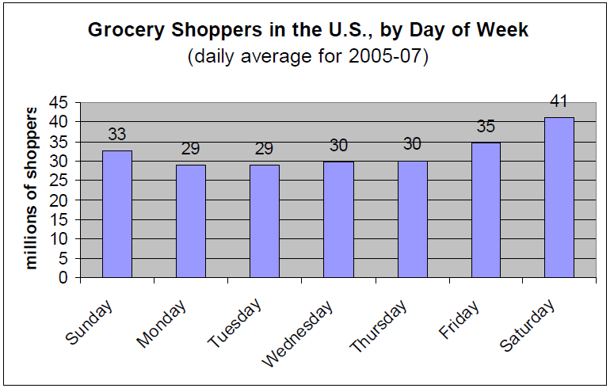
Figure 1: Shown are the days of the week and the amount of people who go grocery shopping on those days. Saturday is the highest with Monday and Tuesday being the lowest.
Source: Jack Goodman, The Time Use Institute

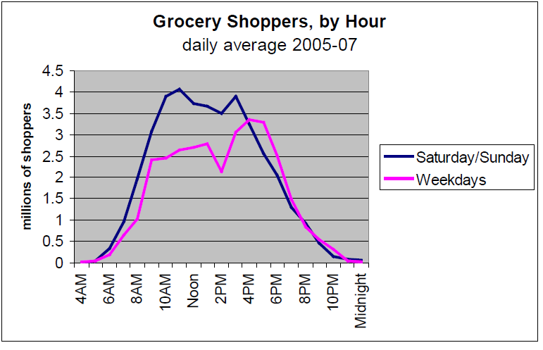
Figure 2: Shown is the amount of grocery shoppers per hour on average. The data is split into the weekdays and weekends but the average shows that most people shop between 3PM and 7PM and the least amount of people shop between midnight and 4AM.
Source: Jack Goodman, The Time Use Institute

Temperature is also an important variable and links in with the type of precipitation that is forecasted to fall. However temperature itself is a determining factor when it comes to sales. For below average temperature scenarios in the winter, people are less likely to venture out in the conditions to shop. Exact forecasted values are used for the short term and medium range indices while comparisons with the “normal” value are used for the long range forecasts (ex: well below average).
Visibility and wind are the next most important variables and they relate to each other. Strong winds and precipitation can lead to low visibilities and hazardous travel conditions. Strong winds by themselves can also lead to hazardous travel conditions. The last variable used is snowfall. If a location has snow on the ground, it can pose a risk especially with strong winds. Blowing and drifting snow will pose travel problems and would likely decrease the amount of people on the road and as a result lower sales at a grocery store. Snowfall forecasts will incorporate past and current data with future forecasted accumulations. Satellite data can be found through the National Hydrologic Remote Sensing Center.
Once all the categories are determined, a simple formula is used to apply the weights and determine the S’no Problem Weather Index (SPWI). The formula is as follows,
SPWI = (VCat₁)*(VW₁) + (VCat₂)*(VW₂) + … + (VCat_{n})*(VW_{n})
where VCat₁ is the category for variable 1, VW₁ is the weight for variable 1, VCat₂ is the category for variable 2, VW₂ is the weight for variable 2, and n is the maximum number of variables used.
A storm severity category is then determined for the SPWI. This label indicates the degree of impact that the storm will have on the grocery store. Table 3 shows the different categories.
Storm Severity Category
SPWI = 0.1-3.5 | SPWI = 3.6-6.5 | SPWI = 6.6-8.9 | SPWI = 9.0-10.0
Low | Moderate | High | Extreme
Table 4: Shown are the different categories that are used to determine the degree of impact that a storm will have on the grocery store.

These labels are used to enable a fast and easy decision for grocery stores to make. With each category comes a list of guidelines that we offer to ensure that the store takes the proper action to prepare for the storm and ultimately save money. Guidelines are included for the day of the weather event, several days leading up to the weather event, and days after the weather event occurred.

Product Example
Below is an example of the S’no Problem Weather Index in action. A hypothetical storm was created for State College, Pennsylvania. It was expected to hit on January 16, 2013. We used all three of our indices to rate the storm severity. In terms of our short term index, weather data from 2 days out was filtered into it as shown in the tan colored box on the Excel spreadsheet. After placing those numbers into our index equation, an index of 7.4 was assigned to that area which suggests a high storm severity on the company. Figure 3 shows this. We also used the medium range and long range index to track the storm and its potential impacts from 7 days out and 14 days out. Figure 4 and figure 5 displays our results.
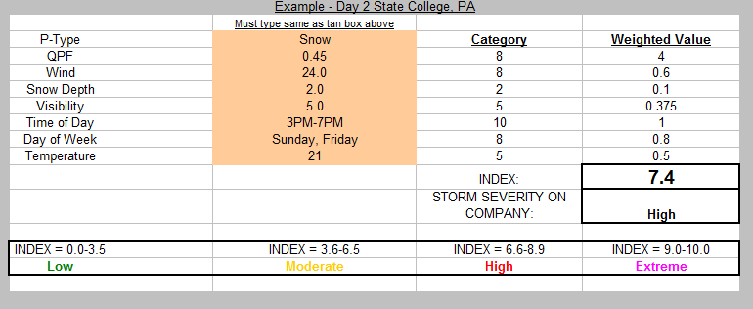
Figure 3: This screenshot shows our S’no Problem Weather Index in action. Weather data is entered into the index and appropriate categories are then assigned, weights are applied, and an index is generated along with the storm severity on the company. This example is our 1-3 Day Short Term Index using weather data 2 days out.

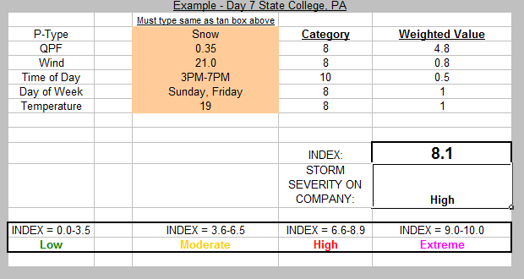
Figure 4: This snapshot shows our 4-7 Day Medium Range Index for the same storm. Data 7 days out was used in this index to predict the January 16, 2013 hypothetical storm for State College, PA. An index of 8.1 was determined with our index 7 days out which is considered high for storm severity on the company.

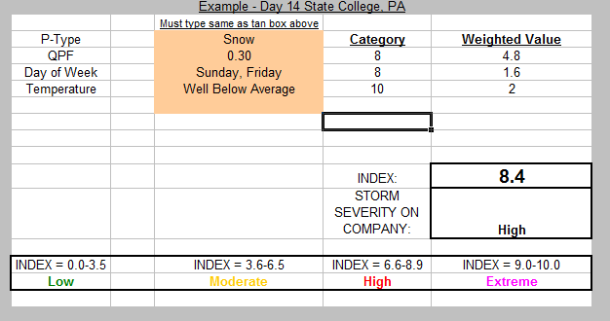
Figure 5: This snapshot shows our 8-14 Long Range Index for the same storm but 14 days out. Data was used in this index to predict the January 16, 2013 hypothetical storm for State College, PA. An index of 8.4 was determined through our calculations which results in a high storm severity on the company.

By using this information and other calculated indices across the region, we are able to generate a S’no Problem Weather Index graphic that can be easily used to make quick and accurate decisions for companies such as Weis Grocery.

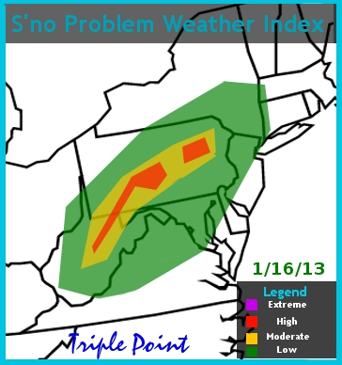
Figure 6: Shown above is the final product of the 1-3 Day Short Term SPWI. A figure showing the storm severity based off of the index will enable grocery stores to make quick and easy decisions regarding their store.

Triple Point’s products will be disseminated through e-mail to the corporate office. This will ultimately be the easiest way to send our product over in reasonable time. We also will offer online video conferences if our client would like a weather briefing or has questions regarding our product. Interested parties are encouraged to subscribe to TriplePoint’s conference call capabilities. For an additional fee, conferences by Skype or other technology will be available to provide person to person communications by one or all of the highly skilled meteorologists of TriplePoint. An individual will call conference managers or employees of Weis markets offering a real-time analysis of weather information and be available for further explanation and interpretation open to any questions interested parties may hold. Information regarding the distribution of our product can be found in the contract.

Guidelines
 | Low | Moderate | High | Extreme
Effects | - Little-to-no effect on business  - Little-to-no chance of delays and closures | - Increased sales due to increased demand of certain goods  - Moderate chance of delays and closures | - Increased business due to increased demand of certain goods before event. Decreased business due to poor travel conditions on day of event  - High chance of delays and closures | - Increased business before event. Decreased business day(s) of event due to extreme conditions  - Delays and closures imminent  - Very severe and crippling event
Days leading to Event | - Business as usual | - Advertising: Base advertising around upcoming storm. Certain goods will have increased demand (canned-goods, non-perishables, water, etc.)  - Stock: Beneficial to have too much stock than to have too little stock. Increase stock on necessary goods to be ready. Additionally, stock up on winter-maintenance goods for the store to use  - Staff: Staff as usual. Prepare winter maintenance workers to keep the store safely operational. Store closures should not be necessary so make sure the staff is aware that their work and help is needed. | - Advertising: Increased demand due to event. Certain goods have increased demand. Advertise the storm and what customers need to safely and efficiently manage the event  - Stock: Beneficial to have too much stock than to have too little stock. Stock up on necessary goods. Make sure the goods are available the days leading to event. Make sure that winter-maintenance goods are available for the store to use  - Staff: Inform employees of the upcoming storm and prepare them for the increased business to create an efficient shopping experience leading up to event. Maintenance workers should be prepared to work as necessary for the days leading to event | - Advertising: Increased demand of specialty goods. Make sure the customers know the store is aware of the event and provide the customers  - Stock: Beneficial to have too much than too little. Stock up on necessary goods. Make sure goods are available days before the event. Winter maintenance good essential.  - Staff: inform the staff of upcoming event, warn them of the caliber. Have winter maintenance staff ready
Day of Event | - Business as usual | - Advertising: Continue to advertise necessary goods. Continue the weekly advertisements because this event will only cause minor delays  - Stock: Maintain stock as usual, but be sure to restock and have specialty items available. | - Advertising: Continue to advertise necessary goods  - Stock: make sure these goods are easily accessible and consistently restocked.  - Staff: Be prepared to dismiss less-essential employees to save on operating costs due to decrease of business. Especially during slower hours, or if the event is occurring on a less busy day. Winter-maintenance staff should be on site and working to create a safe operation | - Advertising: continue to advertise necessary goods.  - Stock: Keep necessary items fully stocked and available, especially during busy hours/times. There will always be people “dumb” enough to travel during the storm.  - Staff: Be prepared to dismiss less-essential employees especially during slow hours/days. Store closure may be necessary to ensure proper and safe management of the event. State of emergency declared by a governing body is important.

Contract
Headquarters – State College, PA
Founded – January 2013
Constituents – Five highly skilled meteorologists educated through the Pennsylvania State University.
TriplePoint Mission:
To provide weather related data to industries to make informed decisions on business operations in response to winter weather.
TriplePoint Vision:
To be the nation’s most helpful and trusted provider of weather indices.
TriplePoint Values:
In order to achieve our mission, we employ top of the line meteorologists with a combined total of 15 years experience in the field of atmospheric sciences.
Business Ethics:
We at TriplePoint believe in conducting a business with a strong ethical backbone and place our customers’ concerns and safety above all. Our product is intended to maximize potential savings due to weather extremes while keeping people’s safety as a top concern.
Our Customers:
Currently TriplePoint is marketing grocery store industries.
Our Product:
TriplePoint currently offers a ‘S’no Problem Weather Index,’ a tool for grocery store managers to utilize in their decision making process of maximizing product sales and preparations for inevitable weather disruptions. Our ‘S’no Problem Weather Index’ is offered in the following three different stages:
*1-3 Day Short Term Index:
This product is the most comprehensive model in terms of the amount of variables, used for immediate implementations for the business.
*4-7 Day Medium Range Index:
This product allows for maximum shipping/stocking savings as well as advertising.
*8-14 Day Long Range Index:
This product allows for maximum advertising with a competitive edge in the industry.
Each index incorporates atmospheric and social variables appropriate in determining guidelines for the grocery store business. These guidelines are to be used in the decision making process including, but not limited to, advertising sales, placing and fulfilling stock orders, lessening spoilage, allocation of employees and increasing sales.
Distribution of S’no Problem Weather Index:
Our products are uniquely created weather indices owned outright by TriplePoint hence TriplePoint will not distribute products on a website or by hardcopy. The weather indices (1-3, 4-7 and 8-14 day products) along with a summation of guidelines for implementation for the grocery store industry will be distributed to the corporate office of Weis Markets in Sunbury, Pennsylvania; after full payment through a designated email service. Interested parties are encouraged to subscribe to TriplePoint’s conference call capabilities as well. For an additional fee, conferences by Skype will be available to provide person to person communications by one or all of the highly skilled meteorologists of TriplePoint. An individual will conference managers or employees of Weis markets offering a real-time analysis of weather information and be available for further explanation and interpretation open to any questions interested parties may hold.
Availability and Update of S’no Problem Weather Index:
The 8-14 Day Long Range Index will be updated and distributed two days a week (Sunday and Wednesday). Sunday the product will likely be helpful to update and prepare for the week of sales ahead. This index will also be provided Wednesday in order to incorporate final decisions on advertising that are sent out to newspapers the following Thursday.
The 4-7 Day Medium Range Index will be updated and distributed two days a week (Monday and Thursday). This index will be helpful in finalizing advertising sales and stock preparations. Allocation of employees will also be beneficial in using this index.
+The 1-3 Day Short Range Index will be extremely helpful in immediate placement/distribution/and fulfillment of perishable and non-perishable winter ready preparedness items due to Weis’ 24-hour order and shipment structure of operations. This product will be updated and distributed once daily.
Pricing:
TriplePoint offers all three indices of the S’no Problem weather Index (1-3, 4-7 and 8-14 day) for purchase for the months of September through May. The following three options for purchase with total costs are as follows:
Monthly: $30,000 ( only ~$185 per store)
3-Month: $85,000 ( only ~$175 per month/store)
Full Winter season: $240,000 (Save a total of $30,000 a season, conference calls included)
*TriplePoint Conference Connection Calls: $100 per call

Exclusive Contract:
This product will be made available exclusively to Weis Markets. This gives Weis the advantage in the grocery store industry to have the opportunity to increase profits from the uncertainty of winter weather. TriplePoint’s ‘S’no Problem Weather Index’ provides Weis the upper hand to compete with local grocery stores such as WalMart, Wegmans, Giant and Giant Eagle.
TriplePoint’s Year-round Commitment:
We at TriplePoint strive to save your business the potential losses due to inevitable weather phenomena. An index currently in development with TriplePoint incorporates different weather variables to extend our product into the summer season. The same team of highly trained meteorologists at TriplePoint will provide interested parties with more information on the availability of this product in the near future.

Terms and Conditions: TriplePoint is not held responsible for any liabilities or legalities in the issue of potential winter weather products. TriplePoint interprets weather information and presents this information to grocery store industries to provide potential impacts of storm hazards and offer guidelines on how to conduct business.

* Refer to page __ for complete descriptions of variables and assembly of indices.
+Depending on severity of storm and timeframe, TriplePoint’s 1-3 Day Short Range Index will be updated and available twice a day at the times of 5:00am and 5:00pm.

Supplemental Resources and References
Goodman , Jack. “Grocery Shopping: Who, Where, and When” The Time Use Institute; timeuseinstitute.org, Oct. 2008; Web; 24 Jan. 2008.
http://www.ametsoc.org/boardpges/cwce/docs/DocLib/2007-07-02_PrivateSectorInMeteorologyUpdate.pdf
http://www.nws.noaa.gov/tdl/pubs/Documents/Papers/Ruth2009ThePerformance_rev.pdf
Weis Markets 2011 Annual Financial Report
Will McDevitt, Manager: Weis Markets, Gilbertsville, PA

