William G. Clark
Senior Student Meteorologist
The Pennsylvania State University
Introduction:
I have been requested by the Bedford County School District to obtain and analyze weather data in and around Bedford, PA, located in Central Bedford County in South-Central PA. The date of inquiry was February 22, 2011. Specifically, I was asked to determine how much snow fell in Bedford, PA in and around this date and whether it was snowing at 7PM LST on the 22nd.
Data Used and Documents Reviewed for this Analysis:
Level 3 NEXRAD Base Reflectivity Radar data from the State College NEXRAD (located just north of State College) for the evening February 21, 2011 through the evening of the 22nd, acquired from the Nation Climactic Data Center.
Level 3 NEXRAD Storm Total Precipitation Radar data from the State College NEXRAD for the storm beginning on February 21, 2011 lasting until 5:44 AM EST on the 22nd, acquired from the National Climactic Data Center.
METAR surface weather observations from the National Weather Service ASOS in Altoona, PA (KAOO) for 7PM EST February 20, 2011 to 7PM February 22, 2011, acquired from the Plymouth State Weather archive page.
Public Information Statement from the State College Office of the National Weather Service issued at 10:28 AM EST on February 22, 2011 for the storm total snowfall starting 24 hours prior.
1000-500mb thickness pressure maps from the NARR for the 5 day span starting February 20, 2011, acquired from the Penn State Meteorology webpage.
Methodology:
Several methods were used to determine the weather conditions, snowfall timing, and amounts in and around Bedford, PA on February 22, 2011.
- Level 3 NEXRAD Base Reflectivity Radar data was used at 10-20 minute intervals to ascertain the timing and coverage of the precipitation across the area.
- Level 3 NEXRAD Storm Total Precipitation Data was used to estimate the total amount of liquid equivalent precipitation that fell across the area for the storm in question.
- METAR surface weather observations were used to determine precipitation amount, type, and duration based on surface temperatures and actual observed weather conditions reported by the ASOS. An ASOS is an automated system that monitors the weather conditions, usually located at an airport.
- A Public Information Statement was used to determine the total snowfall that fell from the storm that occurred just prior to the date in question. This type of statement is regularly released after a notable snow event, and is comprised of measurements taken by trained weather spotters.
- The 1000-500mb pressure thickness maps were used to understand the evolution of the storm in question and the track and intensity of the Low-Pressure system associated with it.
Limitations/Potential Errors:
- NEXRAD Base Reflectivity is limited to a certain radius to which it can detect precipitation. The State College radar has a radius that encompasses the city of Bedford, although it is towards the periphery of the highest degree of detection. Winter weather, especially snow can fall from low clouds, that at this periphery, can fall undetected under the radar beam.
- Storm Total Precipitation is a radar derived product and can be influenced by phenomena that will skew the results of the product. In this case there was a changeover event from rain to snow. This can result in an overly enhanced reflectivity return called bright banding that will cause the totals to over perform. This product also only estimated liquid equivalent precipitation, and other methods have to be used to determine precipitation type and snowfall amounts. Nevertheless, this event had a relatively quick changeover and the estimates should be quite accurate.
- The METAR station that I used was for a location that was approximately 30 miles due north of Bedford in the city of Altoona, PA. This will result in slightly different conditions being observed in the separate locations. However, the trajectory and expanse of the precipitation as well as the similar elevation of the two cities, has led me to believe that totals, type, and duration of precipitation were very similar between the two locations, and that the conditions in Altoona were very close to those in Bedford.
- Public Information Statements with snowfall amounts, although taken from trained observers, are subject to human error in proper procedure in measurement techniques.
Weather Synopsis for February 21, 2011 through the 22nd:
A storm system located in the Ohio Valley during the early part of the 21st began to overspread a light rain over southern Pennsylvania. This light rain persisted through the late afternoon hours until it transitioned into snow around 5PM EST. At this time, the temperatures were in the upper 20s with light winds. The snow fell throughout the night of the 21st at moderate to heavy intensities, before ending as a light snow in the early morning hours of the 22nd around 5AM. By this time, approximately 8 inches of snow had fallen in and around Bedford. Temperatures also fell through the night and were in the low teens by sunrise. Conditions stayed dry throughout the majority of the day on the 22nd with overcast to partly cloudy skies and temperatures reaching to the mid-20s by late afternoon. For the hours leading 7PM EST in Bedford, conditions began to become snowy once again. Starting around 2PM snow flurries and showers started falling, and picked up in intensity starting around 4PM. Light snow continued falling in the area until about 6PM. During the time immediately surrounding 7PM there was a very light snow falling, likely consistent with a flurry, and mostly to the southern part of the county.
Conclusions:
I can conclude based on the variety of meteorological data available that snow did fall in and around Bedford leading up to the date and time in question. There is also evidence and data showing that at 7PM there was a very light snow falling. Based on the Storm Total Precipitation estimates (Figure 1) between an inch and inch and one half of liquid equivalent precipitation fell in Bedford. Approximately three tenths of an inch fell as rain according to the METAR observations (Figure 2), so that leaves seven tenths to one and two tenths inch of liquid equivalent falling as snow. It is common in this temperature to use a ratio of 10:1 when estimating snowfall amount from liquid equivalent precipitation. This would account for 7-12 inches of snow in the Bedford area. Based on the Public Information Statement (Figure 3), 8 inches of snow was measured by a trained COOP observer just to the west of Bedford in Everett, PA, and 7.9 inches was measured just to the north of Bedford in Wolfsburg, PA. Therefore, an amount right around 8 inches likely accumulated in Bedford. 7.3 Inches of snow was measured in Altoona, this leads to the validity that the two locations received comparable weather conditions.
At 7PM EST Base Reflectivity NEXRAD data (Figure 4) shows that there was in fact a band of light snow falling in the county of Bedford to the south. This reflectivity shows a narrow band of snow at around 8-12dBZ which is consistent with light snow. There is also an even smaller band of reflectivity in and just to the north of the city of Bedford. This band however had reflectivity values close to 0dBZ and would either have been a very light flurry or may have not even reached the ground.
The above conclusions represents my educated evaluation of the meteorological conditions surrounding the time and place mentioned above.
William Clark - Senior Student Meteorologist
Figures:
Figure 1: Storm Total Precipitation
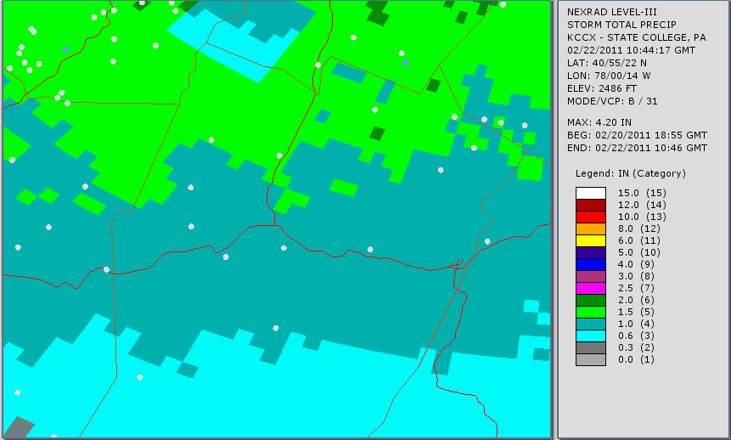
Bedford is the dot at the junction of highway 99 and 76.

Figure 2: METAR Observations from 7PM EST 20th to 7PM EST 22nd
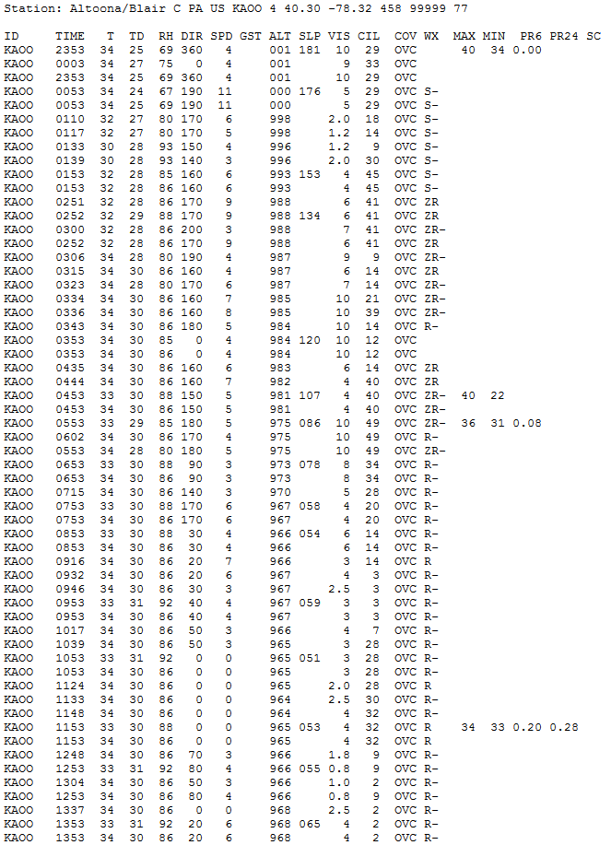
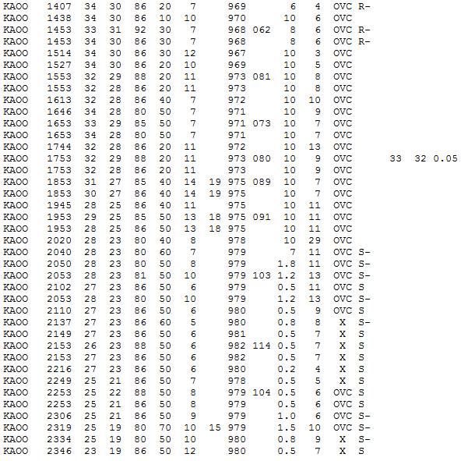
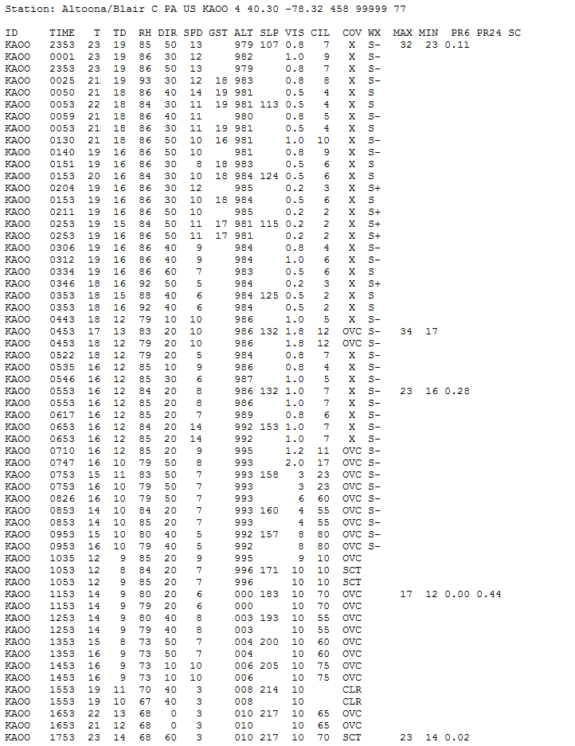
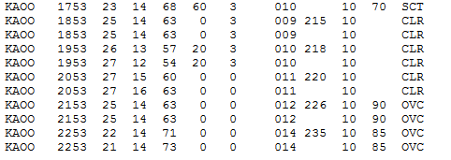
Figure 4: Public Information Statement
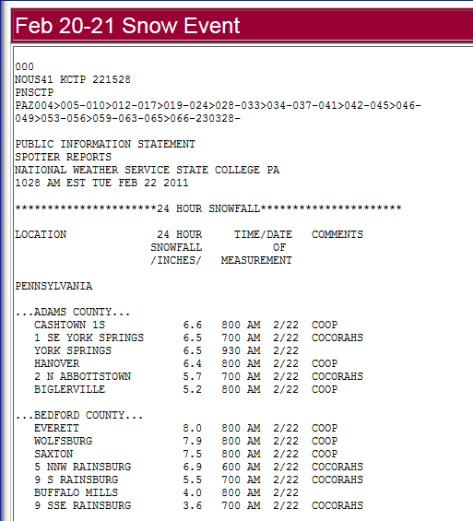
Figure 4: Base Reflectivity at 6:54PM EST
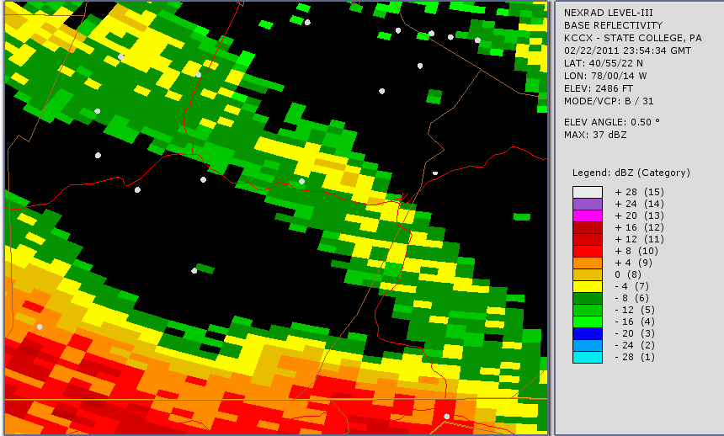
Bedford is the same dot at the junction of Highway 99 and 76.

