The Pennsylvania State University
Global Warming of a Fragile World
Climate Change and Its Impacts for Miami-Homestead Florida and Accra-Tema Ghana
William Grauer Clark
12/17/2012

Introduction:
Climate change is the direst concern facing the globe in the coming years and centuries. Alas a good chunk of the general public still does not believe that climate change is even occurring and many of those that do believe refuse to associate it with anthropogenic causes. The sad reality is that in the coming years many of these non-believers will be enlightened in the harshest of ways. The changes have already begun, we are at the warmest this globe has been in the past 100,000 years and these temperatures will only continue to rise as we pump increasing amounts of greenhouse gasses into the atmosphere. We are faced with the grim reality that storms will become stronger; the current 100 year storm will soon become a 50 year storm. Lands will be drought ridden crops will shrivel, snow packs will dwindle and rivers will leave their banks on more and more occasions. Glaciers will recede as seas acidify. Shorelines will shrink as oceans expand and rise. Coastal cities will be inundated and hundreds of millions of climate refugees will choke already congested metropolitan areas. All of these ominous outcomes are inevitable if we keep up the fossil fuel dependent lives we live today.
In this report I will lay out the climate change specifics and impacts of two vulnerable major cities, Miami Florida, and Accra Ghana, as well as two smaller cities in their immediate vicinity, Homestead Florida and Tema Ghana. I will start with the similarities and differences between the four cities as they relate to climate change. Then I will explain in detail the future climate change and impacts each city is facing. I will conclude with a summary of what I believe are the most pressing concerns that these cities are faced with.

Similarities and Differences:
All four cities lie in Low Elevation Coastal Zones (LECZs) a LECZ is defined as an area 10 meters or less above sea level (Rain). Miami, Accra, and Tema lie directly on the coast while Homestead lies several miles inland. Even though Homestead is not directly on the coast, it along with Tema lies a mere 3 feet above sea level. Miami averages slightly higher at 6 feet while Accra is the highest of the four cities because of its wide expanse it averages 200 feet. These 200 feet are misleading though, because a lot of the poorer neighborhoods, the port, and pristine coastal communities lie just above sea level. Accra isn’t the only city with a port; Miami and Tema also have major ports. Tema’s port is directly linked to Accra via a major highway and rail systems. Miami’s port is the site of Carnival Cruise lines and is a major hub for many other cruise lines.
The climate of the two major cities is quite similar along with the two smaller cities. The climate category for Miami and Homestead is tropical monsoon and Accra and Tema fall under the tropical savannah category. The only difference between the two is the amount and spacing of the rainfall. The climatology for the two smaller cities varies only slightly from the larger ones due to microclimate differences. According to BBC Weather, the annual average high and low for Accra is 86 and 73 degrees respectively. According to NOAA, Miami’s annual average high and low is 84 and 69 degrees. Yearly rainfall for Accra is 28.5 inches and falls mostly in the two wet seasons associated with the shifting ITCZ. Miami has a good deal more rain with roughly 62 inches of rain that falls mostly during summer and early fall convective thunderstorms. Both cities attribute their warm moist climates due to their low latitudes, Miami at 25N and Accra at 5N. Although Miami is 20 degrees higher latitude than Accra, it is almost as warm as Accra due to the influence of the warm Gulfstream just off the coast.
The demographics of the cities are similar in the fact that a large percentage of the citizens migrated in from neighboring and close by countries. In Accra roughly 44 percent of the population came as immigrants from other West African countries. The 2010 US Census reports Miami has roughly 42 percent of its population coming from the Caribbean made up of Cuba, Dominican Republic, Haiti, and Puerto Rico. The United Nations Development Program ranked Miami first in terms of percentage of residents born outside of the country the city is located in. The racial makeup of Homestead is very similar to that of Miami and so is Tema to Accra, due to the close ties the smaller cities have to their bigger neighbors. Poverty is a large problem in the cities, Accra has a large percentage of its population living in slums and unstable poorly built structures. Miami and Homestead have 26 and 31 percent of households living below the poverty line respectively. These poverty statistics are by far the most important demographic, as the poorer residents of these cities are the ones affected most by climate change.
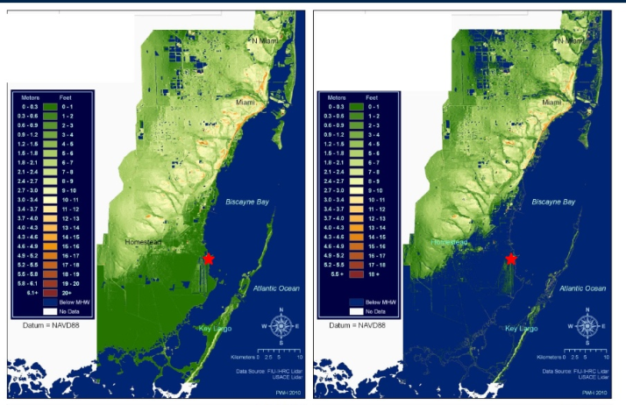
Future Climate Change and Impacts:
Sea level rise is most certainly the largest concern related to climate change for coastal cities. The IPCC predicts that the oceans will rise 1-2 feet by the end of the century, mostly due to thermal expansion of the ocean and melting glaciers in Greenland and high mountain areas. This may not seem like very much but a two foot sea level rise would wreak havoc on all four cities. As you can see on Figure 1 above, Miami-Dade County would see a noticeable loss of land by the end of the century, 28 percent, if no measures are taken to protect the city, and if sea levels rise by two feet. Some effects of this rise are evident while others are not. Miami begins to lose area on its barrier islands and immediate coastal sections. Homestead changes from being several miles inland to being a coastal city with only a foot to spare from the rising tides. Coastal Ghana won’t see such a drastic loss of land as coastal Florida, because the land slopes upward much quicker. Even so, the lowest areas of Accra and Tema will be affected. These low areas in Accra contain most of the poorest residents, as many of the slums are located just above sea level. This two foot rise would severely affect the ports of Accra, Tema and Miami. The inundation of these ports would devastate these cities, 180,000 people are employed by the port of Miami, and Tema’s harbor handles 80 percent of Ghana’s import and export cargo with the remaining 20 percent going through the harbor in Accra. If these harbors had to be frequently shut down in high tide scenarios, the entire country would be shut off from vital supplies. Tourism for Miami and Accra would be severely affected as the pristine beaches that both cities claim would be severely eroded or even become completely underwater.
(Figure 1) LIDAR image of Miami-Dade county as is now (left) and with a 2 foot sea level rise (right). (Wanless)
One of the less evident consequences of this sea level rise is the effect on clean drinking water. A major problem comes from salt water intrusion into ground water near the coast. All four cities will be faced with this problem, but it will be most severe in Miami and Homestead where the porous limestone of the Biscayne Aquifer makes it vulnerable to intrusion. Miami-Dade County may not be able to meet future demand for clean drinking water by as early as 2025. Perhaps an even more pressing issue than running out of water is the contamination of the water that is available due to the inundation of low lying landfills and sewage treatment plants (Root). This problem becomes amplified in Accra and Tema where a large amount of homes do not have piped water access, so the direct contamination of wells by disease and bacteria could lead to illnesses and the need for imported water. Water is such a precious resource and these combined effects will stress the supply for all four of these rapidly growing cities.
Rising temperatures and more varied rainfall patterns will add insult to injury in these four cities. Based on the IPCC fourth assessment, global air temperatures are expected to rise 2-4 degrees C by the end of the century. This increase will be seen more in the higher latitudes than in the tropics and subtropics of West Africa and South Florida, but nonetheless any rise in temperature will stress these cities even more. The days where highs reach above 90 degrees F in South Florida will essentially double from the 1980 amount to the end of the century (Park). A similar trend will be felt in the dry seasons in Accra and Tema where many people can’t afford air conditioners to stay cool, and those who can will feel it in their wallets and stress the local power grids. As cities expand and green space declines the Urban Heat Island Effect (UHIE) will also increase. The UHIE will only exacerbate heat waves in the inner city areas of Miami and Accra increasing the occurrence of heat stress related illnesses and deaths.
Rising temperatures aren’t only occurring in our atmosphere, but in the oceans as well. Changes in ocean temperatures will not only lead to thermal expansion, but also large changes in global climate factors like El Nino Southern Oscillation (ENSO), monsoons, and the position of the ITCZ. The phases of ENSO have a global teleconnection and affect South Florida as well as West Africa. The trends for the positive El Nino phase in Miami and Homestead are for cooler and wetter winter and spring months due to the enhanced southern branch of the jet stream. The negative La Nina phase of ENSO brings the opposite to South Florida. An even more crucial effect ENSO has on South Florida is its influence on tropical cyclone development. The positive phase increases wind shear across the Tropical Atlantic and Caribbean, this helps tear hurricanes apart and lowers storm numbers and strength. The negative phase of ENSO actually does the opposite and relaxes the wind shear leading to more frequent and powerful hurricanes. With sea levels already rising, Miami and Homestead will become increasingly vulnerable to tropical cyclone impacts. The storm surge of a category 1 hurricane will eventually turn into that of a cat 2 or even 3 due to sea level rise. The overall frequency and strength of Tropical cyclones due to Climate change is a highly disputed topic, but with the frequency of the positive El Nino phase predicted to be on the rise Miami might just luck out. ENSO has less of an effect on West Africa because it is a Pacific Ocean phenomenon, but there is evidence that shows the negative La Nina phase provides cooler weather in West Africa.
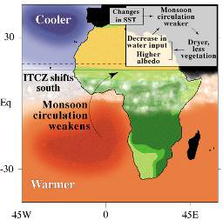
The two climate factors most crucial to Accra and Tema’s weather are the ITCZ and West African Monsoon. As you can see in figure 2 the trend in sea surface temperatures since the mid-20th century has been for a warming in the southern Atlantic Ocean and slight cooling in the Northern Equatorial Atlantic. This change in temperature reduced the land-sea temperature differential and therefore weakened the monsoon circulation. This allowed the ITCZ to shift south over Accra and Tema and increase their rainfall (Conway 2008). This increase in rainfall will occur when the ITCZ shifts over Accra and Tema twice a year, worsening floods and damaging crops. In Accra many of the poorest neighborhoods live right along the Odaw River and will be the hardest hit when floods come. The ITCZ shift won’t affect the dry season rainfall, and prolonged droughts are still possible even if the overall yearly rainfall goes up. Flooding will also be an increasing problem in the Miami Homestead area. As the sea levels rise there will be less of an elevation difference between the drainage channels and the ocean, this will slow the ability for storm water to drain and add to flooding inland during intense rain events.
(Figure 2) Change in West African Monsoon and ITCZ due to changes in land-ocean temperature differential. (Conway)
Summary:
As I hope I made quite evident throughout my entire paper, the effects of climate change will be almost entirely detrimental to all four cities. These impacts will be felt by the poor much worse than the affluent; because of their inability to bounce back from major traumas quickly. Sea level rise will be the single most detrimental impact on Miami, Homestead, and Tema due to land area loss, port inundation, and drinking water contamination. Likely the greatest affect to Accra will be the increase of flood events in the rainy seasons that will overflow the rivers and drainage channel’s banks and destroy the poorly built slum neighborhoods. Temperatures will rise in all of the cities increasing the risk of heat related illnesses and evapotranspiration. Ocean temperatures will rise and cyclones will become increasingly more potent as buffer zones and land disappears.
All of these scenarios seem inevitable based on the actions that a majority of the world is taking to combat climate change. I still believe there is some hope though. An increasing amount of cities and countries worldwide are beginning to open their eyes to climate change and are setting regulations to combat climate change and reduce their carbon footprint. If we all act now it just might be soon enough to prevent a snowball effect of rising temperatures and preserve this beautiful planet for our grandchildren and the many generations to come.

Works Cited
Conway, Gordon. "The Science of Climate Change in Africa." . N.p., n.d. Web. 16 Dec 2012.
Park, Timmothy. "Southeast Impacts & Adaptation." . EPA, 14 2012. Web. 16 Dec 2012.
Rain, David. "Accra Ghana: A City Vulnerable to Flooding and Drought-Induced Migration." . Global Report on Human Settlements 2011, n.d. Web. 16 Dec 2012.
Root, Tara. "Florida Water Management and Adaptation in the Face of Climate Change." . State University System of Florida, n.d. Web. 16 Dec 2012.
Wanless, Harold. "Accelerating sea Level Rise: Florida's Tenuous Coastal Future." Marshal Plan. Palm Beach State College, 10 2012. Web. 16 Dec 2012.

