Lightning: The good, the bad, and the shocking

A report by William Clark and Brett Sattazahn

Submitted April 4th 2011

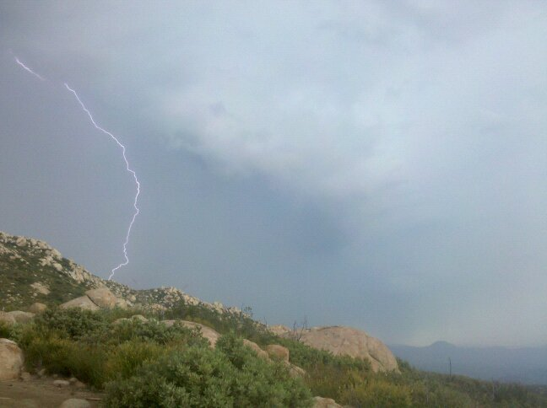

This report introduces the formation process, examines the biological benefits and clarifies common misconceptions and safety tips in regards to lightning
Table of Contents

List of exhibits……………………………………………………………………………………………………………………
Executive Summary…………………………………………………………………………………………………………..
Introduction………………………………………………………………………………………………………………………
Scope, limitations, and methodology………………………………………………………………………
Report organization………………………………………………………………………………………………
Common misconceptions………………………………………………………………………………………………….
Lightning never strikes the same place twice………………………………………………………….
Carrying an umbrella or metal objects will attract lightning…………………………………..
Proximity to storm and possibility of being struck………………………………………………..
Heat lightning……………………………………………………………………………………………………….
Lightning can’t occur below freezing………………………………………………………………………
Lightning formation process………………………………………………………………..
Electrostatic induction………………………………………………………………
Leader formation and the return stroke……………………………………
Thunder…………………………………………………………………………………..
Types………………………………………………………………………………………………….
Cloud to ground………………………………………………………………………..
Cloud to cloud……………………………………………………………………………
Intra-cloud………………………………………………………………………………….
Cloud to space……………………………………………………………………………
Ball lightning………………………………………………………………………………
Biological effects………………………………………………………………………………….
Nitrogen fixation……………………………………………………………………….
Wildfires…………………………………………………………………………………..
Safety…………………………………………………………………………………………………
Outdoors………………………………………………………………………………………………………………..
Indoors…………………………………………………………………………………………………………………..
Conclusion…………………………………………………………………………………………………………………………..
Summary………………………………………………………………………………………………………………

Executive Summary
This report covers five main sections related to lightning – common misconceptions, formation/process, differing types, biological benefits, and finally safety information. The common misconceptions section debunks myths like: lightning never strikes the same place twice, and small metal objects on your person will attract lightning, by revealing that lightning has no bias for or against any particular location, and is only influenced by objects of large scale like skyscrapers. It also clarifies myths on proximity and temperature, by explaining the dangers of lightning even miles away from a storm (bolts from the blue) and that heat lightning is not simply a result of hot stick nights, and introduces the interesting event known as thundersnow.
The formation/process section focuses on the dynamics that go on inside a thunderstorm. The fact that ice pellets known as graupel or hydrometeors crash together inside a cloud building up a powerful charge separation; usually a positive charge in the upper portion and negative charge in the lower portion. It looks at the process of discharging the built up energy, through a cloud-to-ground strike; where first a negatively charged stepped leader descends from the cloud creating a channel of electrified (ionized) air as it jumps down. Then the positive streamer rises up from the ground, eventually meeting the negative stepped leader, resulting in the powerful return stroke that we all recognize as lightning. Thunder is also explained, by describing the way the air is superheated and exploded, as the lightning passes through, resulting in a cacophonous boom that trails the flash by 5 seconds per mile.
The types section of this report describes both common and uncommon forms of lightning and how they come to be. The common forms being: cloud-to-ground, inter-cloud, and intra-cloud lightning. It is explained that cloud-to-ground is the most dangerous of the common lightning types, and that inter/intra-cloud lightning is the most common, with a formation process very similar to its dangerous cousin.
The uncommon forms of lightning consist of: positive, upper-atmospheric, ball, and dry lightning. Positive lightning being essentially the process of cloud-to-ground but flipped, fitting seeing as it is also known as ground-to-cloud lightning. Upper-atmospheric lightning is comprised of three interestingly named types: sprites, blue jets, and elves. Sprites and elves occur well above the highest thunderstorms from electrical discharges being propelled towards space; with blue jets being essentially lightning strikes shooting from cloud-to-space. Ball lightning is a highly controversial take on lightning possibly forming through plasma clouds or oxidizing chemical energy. Finally dry lightning is the term referring to lightning occurring without precipitation reaching the ground, by normal or pyrocumulus (volcano, wildfire) clouds.

What Are Some Common Misconceptions?
Lightning is a very mysterious beast. Most people don’t know the first thing about lightning and how it works. Therefore it is not surprising that these people will believe common myths and even clichés pertaining to lightning and its tendencies, form, and function. I have listed a few of the most common lightning misconceptions, and the truth behind the myths.

Lightning never strikes the same place twice

This saying is one of the most widely used lightning clichés, and couldn’t be further from the truth. A strike to any single location does nothing to change the electrical conditions of the storm above, nor does it create some magical barrier preventing another strike from occurring. In fact, lightning data shows that in areas like Pennsylvania with moderate lightning activity, any typical quarter-acre area of land is hit once every 100 years. For areas with high lightning activity such as Florida, this time period only shrinks between strikes (Robinson).

The statistic that really blows this myth out of the water is the fact that tall buildings and TV towers (over 1000ft) can be struck numerous times even within the same storm. The Sears tower in Chicago is struck on average 40-90 times per year! A park ranger from Virginia, Roy Sullivan, has himself been struck by lightning 7 times (Robinson)!
Exhibit 1: Size Comparison of Sears Tower and Storm Cloud

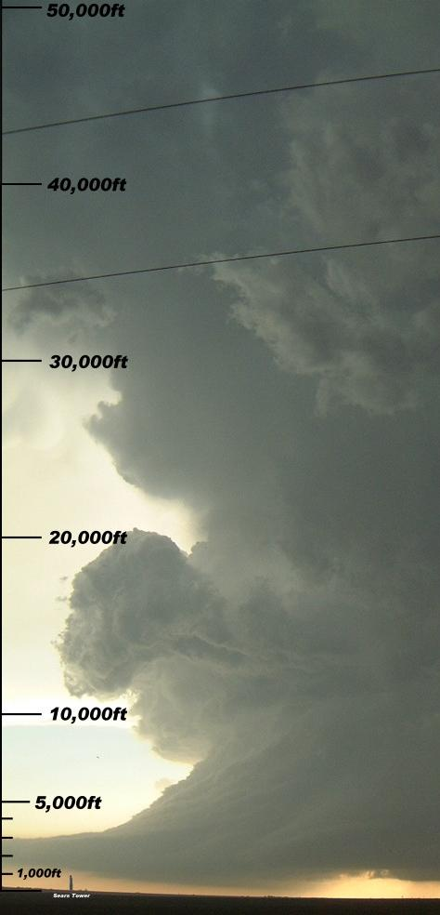
Carrying an umbrella or wearing metal will attract lightning

This myth is one that has a small grain of truth, but is flawed in scale. Saying that an umbrella or metal jewelry attracts lightning is like saying it was the straw that broke the camel’s back. Lightning occurs on much too large of a scale to be affected by small objects on the ground. The position of the storm overhead determines the placement of a lightning strike.

Picture a strong storm reaching up to 55,000 feet into the atmosphere which generates a bolt that is miles long, and you can see why an i-pod, three foot umbrella, even a house would have little to no affect on such a large scale process. Exhibit 1 shows the sears tower superimposed to scale under a strong storm. Hopefully this makes it clear that your nose stud in no way influences a massive bolt.

The descending stepped leader of a bolt doesn’t decide what to strike until it is very close to the ground. So for a three foot umbrella to attract the strike, the lightning would have to already be set to strike within three feet of your location, and by then it is already too late (Robinson). Next time you find yourself out in a storm, don’t take the time to strip your jewelry and underwire bra, instead high-tail it to proper shelter.
Source: Robinson

The arrival of a storm must be imminent to be struck by lightning

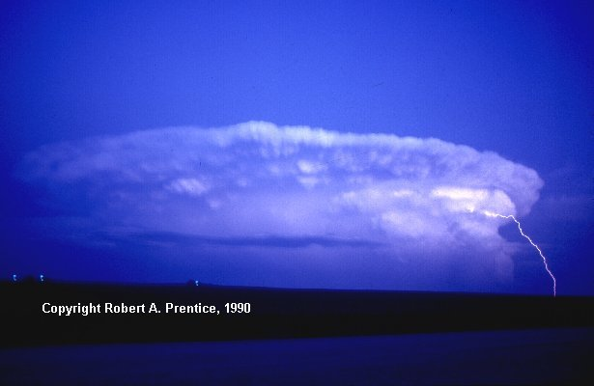
This misconception is also a very dangerous one. Many people believe that it is safe to continue their golf game or keep pulling weeds until a storms arrival is imminent or it begins to rain. In fact lightning can strike up to 20 miles away from an approaching in what is called blue lightning, or lightning that appears to come out of the blue sky. In Exhibit 2, lightning can clearly be seen striking far from the base the storm. So to be safe, at the first sound of thunder it is time to seek shelter, and you want to stay in that shelter for at least 30 minutes after rain has stopped and thunder can no longer be heard (Lightning Safety).
Source: Lightning Safety
Exhibit 2: Bolt From The Blue

“Heat” lightning is caused by hot weather

Heat lightning is simply an unofficial name given to normal lightning strikes that occur too far away for thunder to be heard. These storms may be below the horizon and the flashes from the tops of the clouds could be what is seen flickering in the night sky. Heat lightning most likely got its name because it frequently occurs on hot summer night when summer storm are most abundant. These flashes are not dangerous yet, but could be an early warning sign that a storm is approaching (Robinson).

Lightning can’t occur below freezing

This myth is fundamentally flawed for two main reasons. The first reason is that high up in the storm clouds where lightning is formed, the temperatures are well below freezing. Even on a hot July day where the temperature may be 95 degrees on the ground; the temperature 50,000 feet up in the cloud is likely to be below 0. The second reason this myth is flawed, is that thunderstorms can form in the winter months in rapidly intensifying cyclones (Robinson). When snow is falling at the same time as lightning is occurring, the aptly named term thundersnow is used.

What is the Lightning Process?

Lightning is a very complex process, and the exact cause and formation is still under debate. The following section will focus on the common consensus of scientists, and the most likely process that is undergone in a thunderstorm. There is a lot more to it than when you scoot along the carpet in socks and shockingly awaken the slumbering Fido.

Electrostatic Induction

Electrostatic induction is the most likely formation process for lightning. This process begins high up in the thunderstorm where temperatures are below freezing, and ice pellets called hydrometeors are being tossed about by updrafts within the cloud. These hydrometeors collide with each other and break apart. The smaller particles that break off acquire a positive charge, while the larger chunks hold a negative charge (Goodman).

The smaller particles are carried up, with the ice crystals, inside the cloud by updrafts and allow for a positively charged upper portion of the storm. The larger particles are pulled down by gravity and coalesce with each other in wet ice clumps called graupel (Goodman). The graupel hovers in the mid and lower portions of the storm and allows for a negatively charged area.

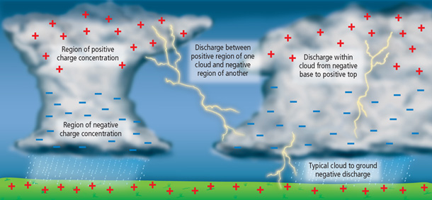
The separation of charge produces a huge electric potential, both between the top and bottom of the cloud, and the bottom of the cloud and the ground. When this electric potential grows to be strong enough, it initiates a discharge that we know as lightning (Goodman). Exhibit 3 shows the charge distribution, and lightning discharge: within a cloud, between clouds, and between a cloud and the ground.
Exhibit 3: Normal Charge Distribution
Source: Jason Project

Leader Formation and the Return Stroke of cloud to ground strike

As a charged storm moves across the surface of the earth a charge is created on the ground that is both equal and opposite to that of the storm cloud. This is usually a positive charge, and it follows the cloud as it travels. When the electric potential between the cloud and ground becomes sufficient, a streamer begins to propagate down towards earth (Lightning).

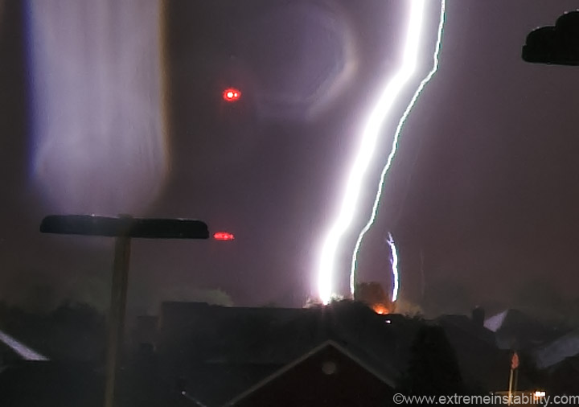
This negatively charged streamer creates a channel of ionized air as it deposits charges on the way down. The streamer travels down in quick jumps or (steps) of about 50m-100m each. Because of the stepped motion of the streamer, it is named a stepped leader. The stepped leader may branch or fork on the way down, and only leaves a channel of relatively insignificant current that is most of the time not even visible (Goodman). As the negative stepped leader gets close to the ground, the opposite positive charges enhance the electric field, and if strong enough will even send up a positively charged streamer, as is clearly shown in Exhibit 4. The real action occurs when these two streamers meet.
Exhibit 4: Positively Charged Streamer

When a complete channel of ionized air is created, a path of least resistance is established. At this point, a massive amount of energy is then transferred up this path from the earth to the cloud, called the return stroke. This is the brightest flash and most intense moment of the lightning’s short lifespan. Any given bolt has an average of 4 return strokes, and this is why lightning often seems to flicker (Salem).
Source: Schyma

Thunder

Lightning almost instantly cooks the air in its immediate vicinity to over 36,000 degrees, or three times the temperature of the surface of the sun! This rapid heating and expansion of the air creates a supersonic shockwave in the surrounding clear air. As this shockwave decays into an acoustic sound wave, thunder is born (Goodman).

Even though the return stroke’s flash and resulting sound wave occur at essentially the same time; the light from the flash travels one million times faster than the sound of the thunder. For this reason, we often see the flash of lightning before hearing the accompanied boom of thunder. Sound travels at approximately one fifth of a mile per second (Lightning). So to gauge the distance (in miles) between the lightning strike and yourself, you need to just count the time between the flash and boom and divide by 5.

What Are the Different Types of Lighting?

As made clear in the previous section on formation, lightning is a very complex process. As a result, it is not surprising that there are many different forms which lightning can take. There are common forms that you can see in any afternoon thunderstorm. There are also some very uncommon forms that you will probably never see, and have only been documented on rare occasion.

Common Forms of Lightning

There are three forms of lightning that are the most common – cloud-to-ground, inter-cloud, and intra-cloud. The first, as its name infers, is the strike that originates from the base of a cloud and stretches down to the ground. The mechanics of this type of lightning was discussed in greater detail in the section on leader formation and return stroke. Cloud-to-ground lightning is the second most common type of lightning and by far the most dangerous. If there are warnings for cloud-to-ground lightning issued, it is imperative that you seek shelter immediately.

The most common form of lightning is the pairing of inter, and intra-cloud lightning. The process and formation of inter/intra-cloud lightning are the same as cloud-to-ground lightning, despite a few differences. In inter-cloud lightning, the stepped leader stretches from the negatively charged section of one cloud and connects to the positive leader from an adjacent cloud (Goodman).
Exhibit 5: Sheet Lightning

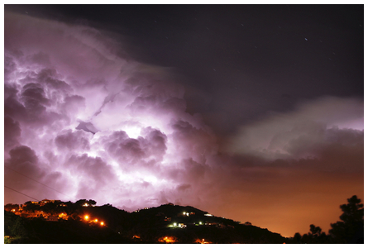
Intra-cloud lightning sends the stepped leader from the negatively charged bottom portion of a cloud up to the positively charged top portion of the same cloud. This form is also known as sheet lightning, pictured in Exhibit 5, because of the sheet of light it creates without a visible bolt (Lightning). These two forms of lightning pose little threat to people, unless they are flying in a plane, shuttle, of lawn chair tied to weather balloons.

Uncommon Forms of Lightning
Source: Jason Project

The more uncommon forms of lightning come about from unique set-ups within the parent cloud. They are rare and some can be very beautiful and harmless while others can be deadly.

Positive/Ground-To-Cloud Strike

A positive strike is one that totally reverses the normal process of a cloud-to-ground strike. Instead of a negative stepped leader stretching from the cloud down, it instead stretches from the ground up. This occurs when a cloud (usually an anvil shape) has a reversed polarity with the negative charge held in the upper portion of the cloud. This form of lightning is the cause of “bolts from the blue”, because the positive leader will often stretch horizontally several miles from the anvil before striking down to meet the negative leader rising up from the ground (Lightning).

The extra length associated with positive strikes leads to an increased voltage of 6-10 times that of a normal negative strike, and a strike duration increase of 10 times as well. These qualities make positive lightning the most dangerous form of lightning. After the discovery of the increased power of positive lightning, it was found that most airplanes are not rated to sustain such a high voltage. Luckily positive strikes make up only 5% of all lightning (Salem).

Upper-atmospheric Lightning: Sprites, Blue Jets, and Elves

Upper-atmospheric lightning is a term that refers to electrical discharges that occur above the tops of clouds and shoot up into the upper atmosphere. They fall under three categories – sprites, blue jets, and elves; all of which are depicted in Exhibit 6.

Sprites are large-scale electrical discharges which are the result of positive lightning strikes between the cloud and the ground. They occur high above the cloud in an area 50-90 miles above the surface of the earth. They are characterized by reddish-orange columns stretching up into the mesosphere, with bluish trailing tendrils, and red arching branches above. Sprites got their name from an air spite in Shakespeare’s A Midsummer Night’s Dream (Lightning).
Exhibit 6: Sprites, Blue Jets, and Elves

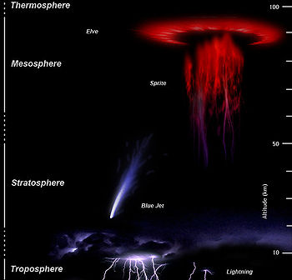
Blue Jets differ from sprites in that they originate from the tops of storm clouds and shoot upward into the stratosphere. Blue jets, as their name implies, are blue in color and also much brighter than sprites. They are in the shape of cones and shoot up 25-50 miles above the earth’s surface into the lower ionosphere (Salem).

Elves are seen as dimly lit, flat expanding glowing discs up to 250 miles in diameter. They occur above thunderstorms in the ionosphere about 60 miles above the ground and usually have a reddish hue. Elves are actually an acronym for, Emissions of Light and Very Low Frequency Perturbations from Electromagnetic Pulse Sources, which is quite a mouth full to say the least. The long title has to do with how elves are formed through the excitation of nitrogen by electron collisions, giving elves their reddish glow (Lightning).
Source: Lightning

Ball Lightning

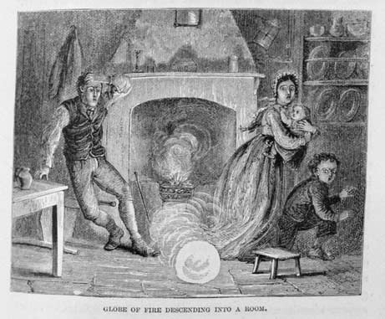
Ball lightning is a very controversial subject, and may not be related to conventional lightning whatsoever. However, ball lightning has been observed and documented for hundreds of years and there are believed to be around 10,000 documented cases. Sightings range in description from pea to beach ball sized spheres of glowing light. These orbs have been seen floating through the air or erratically rolling along the ground (National Geo. News). Some accounts even describe the orb coming down the flu of the chimney and entering the living quarters, as depicted in Exhibit 7.
Exhibit 7: Ball Lightning

Although the cause is still highly controversial, there are two possible explanations for this phenomenon. The first is that the ball is made up of plasma clouds (charged particles that recombine into atoms and glow with light), possibly created by an energy source like conventional lightning. The other being, small particles held together in a ball by electrical charges emit chemical energy through oxidation, after lightning strikes a surface creating a condensing vapor (National Geo. News). Whether or not either of these theories is correct, ball lightning is still a fascinating phenomenon.
Source: National Geo. News
Dry Lightning

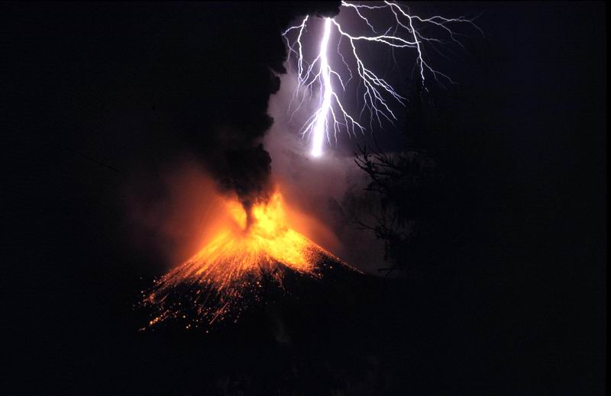
Dry lightning is a term given to lightning that occurs without precipitation present. It can occur in two forms: normal cumulonimbus clouds, and pyrocumulus clouds. Dry lightning occurs in regular clouds when they form over a very hot and dry air mass. This causes the precipitation to evaporate before reaching the ground (Than).
Exhibit 8: Dirty Lightning

Pyrocumulus clouds produce what is also called a dirty thunderstorm. These clouds can be caused by large wildfires, volcanic eruptions, and even thermonuclear explosions. In the case of a volcanic eruption, lightning is caused by the collision of dirt, dust, and debris particles that are hurled into the air by the powerful explosion. These particles build up a charge in the debris cloud until it is discharged as lightning, as depicted in Exhibit 8. A detailed explanation of dry lightning from wildfire smoke plumes is given in the section on wildfires (Than). Benefits to the Environment
Source: Than

Many scientists believe that the beginning of life on this planet may have been caused by lightning rearranging molecules in such a way that they formed DNA. Although this theory has never helped the human race with anything of substantial importance lightning can provide several positive outcomes to the natural world which have been copied:
- Nitrogen fixation
- Clearing of brush and forest floors
- Beautiful displays in the sky
The first two of these will be discussed in greater detail.

What is nitrogen fixation?
A key nutrient to plants’ survival is nitrogen. Although nitrogen is abundant in the atmosphere, it is often the limiting nutrient in plant growth. As seen in exhibit ( ) the nitrogen cycle is a complex process with many different pathways which the nitrogen can take. Lightning provides one of the pathways, fixing atmospheric nitrogen. The way lightning fixes nitrogen is copied for the production of fertilizers utilizing a process called the Haber process.
Exhibit () The Nitrogen Cycle
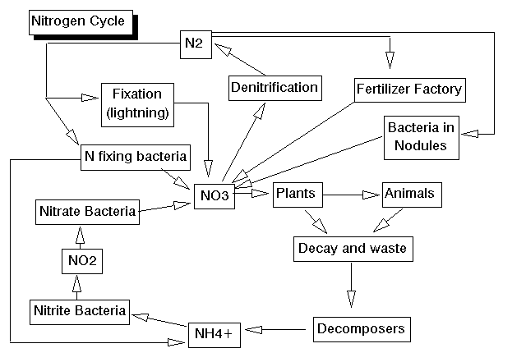
Lightning takes nitrogen from its natural state which is as a gas by itself and attaches oxygen molecules to it creation nitrogen oxides, most often NO₃. The fixed nitrogen is provided to the soil when it rains.

Lightning is not the only natural phenomenon which fixes nitrogen, certain bacteria also fix nitrogen for plants uptake. Many plants have formed a symbiotic relationship with a species of bacteria so they both can grow effectively.
Diagram source: The Nitrogen Cycle

Bacteria fix twice the amount of nitrogen as lightning which converts between 10¹² -10¹³ grams of nitrogen per year (Kasting).

Can good come from forest fires?

Each year 4,000,000 to 5,000,000 acres of forest land and underbrush is cleared by wild fires in the United States. 1 out of every 5 of these 100,000 wild fires is started by dry lightning. Dry lightning is lightning absent from rainfall. There can be two causes for this to occur; the first is that it is too dry for the rainfall to reach the ground, because it evaporates midair( virga). The second type is a dry thunderstorm; these storms have clouds which are very high in the air, causing the rain that is falling to not even get down to the point where it can be seen as virga, lightning is able to reach the ground without water to prevent the ignition of a fire.
Exhibit ()
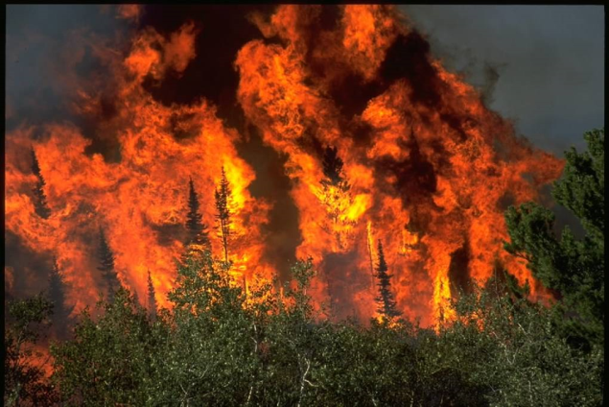
Once the fire is ignited the amount of wild land it will cover is dependent on two things, fuel and oxygen. Fuel is provided by the forest and brush and even homes if they are present. Oxygen is always present as a natural gas present in the atmosphere.

So how can a force as destructive as exhibit () on the right do any good for the environment? The answer is quite simple, nutrients need to be recycled and the forest floor can often get cluttered and the extra space a wild fire provides is beneficial to fortuitous plants.
Picture source: 3story.com

Once the fire is started it produces massive smoke clouds. These clouds either add to the already active storm or can create their own thunder storm producing more lightning bolts which can spark more fires if the area is not already burning (Lyons). A group of Nevada ranchers are seen below in exhibit () as lightning formed by the smoke cloud of an approaching wild fire strikes near their residence.
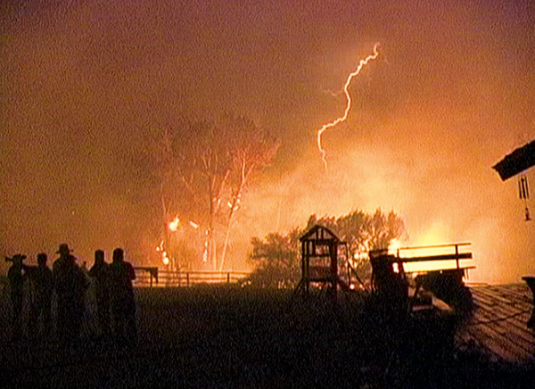
Exhibit (): Smoke lightning

Combustion, such as a forest fire, fixes nitrogen in a similar way to lightning. Other nutrients are also recycled including carbon and magnesium.

The space on the floor allows seedlings to grow and with the additional light reaching the floor since the canopy is also decreased by fire the seedlings have a much higher chance of surviving than normal with a crowded floor and little sunlight. The wild fire provides the new seedlings with fertilizer in the form of recycled nutrients as well as space and light with which to grow.
Picture source: National Geographic

Can lightning make glass?

Glass is created by heating quartz or silica. These minerals are found naturally in the environment and when struck by lightning which is well over the temperature needed to create the glasslike texture, tubes are formed called fulgurites. The lightning formed fulgurites often take the shape of the lightning as it entered the ground, but can also form along cracks already present in rocks.

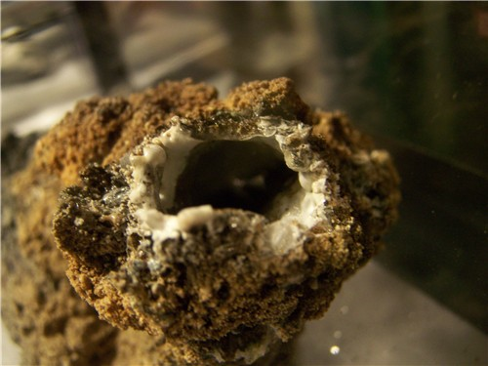
Exhibit (): fulgurite formed by lightning in sand

When lightning forms fulgurites in sand the center of the tube is hollow and the outsides are glass with sand stuck to the glass. This is shown to the left in exhibit (). These fulgurites are found in true sandy soils in which the other soil particles, silt and clay, are absent. Areas which contain these conditions include the beach and deserts.
Picture source: AccuWeather.com

Rock fulgurites are formed by lightning striking the surface of a rock and creating a crack or channel. Due to the repeated striking of mountaintops rock fulgurites are often found at the peak or summits of mountains. The difference between a normal crack in a rock and fulgurites is that the fulgurites have a glazed surface from the intense heat of the lightning. An example of rock fulgurites is given to the left in exhibit ().

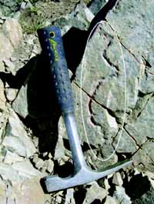
As you can see in exhibit () the fulgurites are several inches long and appear to be grooves or channels in the rock. The cracks also going through the rock are not fulgurites as they do not have the glazed surface present in the channel formed by the lightning bolt.
Exhibit (): Rock fulgurites
Safety
A firsthand account from a lightning survivor, Dean Rick recounts his story by saying, “I was trying to finish a round of golf with my friends when it started storming. We didn’t think anything of it and there wasn’t any cover to be had anyways. Then a lightning bolt struck the ground 15 feet from where I was standing and I watched as a blue light shot to my golf shoes and knocked me off my feet. It rattles you, getting knocked off your feet by light. I am just lucky the lightning didn’t strike 15 feet in my direction, or I probably wouldn’t be here today.
Picture source: Utah

During the past 30 years lightning kills an average of 58 people per year, so Dean can consider himself very lucky. There are also averages of 300 reported lightning injuries each year in the United States alone (National). So how can you protect yourself from becoming one of these statistics?

What should you do if you are caught outside during a thunderstorm and can’t get to shelter?

There is nothing you can do to insure your safety if you are caught outside in a thunderstorm. Several things can be done to slightly lessen the chance of injury or fatality. The safest thing you can do if at all possible is get to an enclosed building or vehicle, if this is not at all possible here are some tips to remember (National):
- Avoid open fields
-Get to an area where you are not the tallest object.
- Avoid tall single trees or other tall objects
-If you get caught in a forest try and find a patch of short trees
- Tents do not offer protection
-If you are camping set up camp in a low valley or ravine.
- Avoid water
-Water conducts electricity and should be avoided at all costs.

What should you do if you are inside during a storm?

The safest place to be during a lightning storm is inside a secure building with electrical wires and or plumbing. If the building is struck, the current will pass through the wires or the plumbing to the ground. The second safest place to be is in a hardtop vehicle.

When in a house stay away from things connected to the electrical wires such as televisions and wired phones. The lightning could pass through the electronic devices if the house is struck and electrocute you if you are close enough. Avoid plumbing such as showers, sinks, or hot tubs. Lightning passing through the plumbing can cause injury if its path to the ground is impeded upon (National).

Glossary

Words listed in order of appearance

DNA- Deoxyribonucleic acid, used by all living cells to communicate to one another and tells the body what proteins to make.

Limiting Nutrient- The mineral a plant must get more of before it can grow at optimum levels.

Haber Process- Utilized by the fertilizer industry methane is reduced to ammonia which is able to be utilized by plants.

Symbiotic relationship- When two organisms both benefit from interaction.

Works Consulted

Ecology, new ecology study results from Swedish university of agricultural science described. (2010). Science Letter, 1357.

Duncan, Brean. Isolating the Lightning ignition regime from a contemporary background fire regime in East Central Florida.

The Nitrogen Cycle. Marietta. Environmental Biology

Martell, D. L., & Sun, H. (2008). The impact of fire suppression, vegetation, and weather on the area burned by lightning-caused forest fires in ontario. Canadian Journal of Forest Research/Revue Canadienne De Recherche Forestiere, 38(6), 1547-1563.

Nieto, H., Aguado, I., & Chuvieco, E. (2006). Estimation of lightning-caused fires occurrence probability in central spain. Forest Ecology and Management, 234, S67-S67.

"Lightning." McGraw-Hill Concise Encyclopedia of Science and Technology. 5th ed. New York: McGraw-Hill Professional, 2005. 1252-1253. Gale Virtual Reference Library. Web. 13 Mar. 2011.Document URL

Salem, Tom. How does lightning and thunder form?. Noaa. Web. 13 Mar. 2011.

Godfrey, Christopher M. Lightning. University of North Carolina. Web. 13 Mar. 2011.

National Weather Service. Lightning Safety. NOAA.Web. 13 Mar. 2011.

National Weather Service. Lightning Safety, the underrated killer. NOAA. Web. 13 Mar. 2011.

National Geographic News. Ball lightning, a shocking scientific mystery. National Geographic. Web. 13 Mar. 2011.

The Nitrogen Cycle. Nitrogen fixation. Web. 23 Mar. 2011.

Postgate, John R. The fundamentals of nitrogen fixation. New York: Cambridge, 1982. Print.

Kasting, James F, et al. “Biogeochemistry: the nitrogen fix.”Nature. News and Views. 5 Jul. 2001. Web. 13 Mar. 2011.

Forbes, Dr. Greg. Dry lightning and dry microbursts. The Weather Channel Blog, 2007. Web. 20 Mar. 2011.

“Wildfires: Dry, Hot, and Windy.”National Geographic. Web. 19 Mar. 2011.

Lyons, Walter A, et al. “Enhanced positive cloud-to-ground lightning in thunderstorms ingesting smoke from fires.”Science 282 (1998): 77-80. Web. 20 Mar. 2011.

Ege, Carl. “What are fulgurites and where can they be found?” Utah DNR. Utah.gov. Jan. 2005. Web. 30 Mar. 2011.

Than, Ker. “Fires can create “volcanic” thunderclouds.”National Geographic. Web. 30 Mar. 2011.

“Fulgurites: lightning turns sand into glass.” AccuWeather.com. Web. 30 Mar. 2011.

Robinson, Dan. Storm Highway. Dan Robinson, 2009. Web. 29 March 2011.

Goodman, Michael. Lightning and Atmospheric Electricity Research. NASA, 2010. Web. 29

March 2011.

Lightning. Wikimedia Inc. 26 Mar. 2011. Web. 29 March 2011.

Jason Project, The. Lightning and Thunder. JP, 2010. Web. 29 March 2011

Schyma, Jason. Stormtrack. Jason Schyma, 2011. Web. 29 March 2011

